**Tutorial 4 (Part A)**

**Part A – Selection Control Structure**

1. Suppose we take input *x* as an integer.

int x;

cin >> x;

Write the ifstatement that runs under the specified condition below. The first one is done for you as an example.

1. x is a positive number

**if ( x > 0 )**

(b) x is between 3 and 30, including 3 and 30

(c) x is an even number, not including zero

(d) x is a number that ends with zero, such as 420

1. A company has decided to raise the salaries of its employees. The company will determine the percent rise based on the status and years of service of each employee.

|  |  |  |  |
| --- | --- | --- | --- |
| **Employee Status** | **Literal** | **Years of Service** | **Percent Raise** |
| Full time | ‘F’ | Less than 7 years | 5.0 |
| Full time | ‘F’ | 7 years or more | 7.0 |
| Part time | ‘P’ | Less than 7 years | 3.5 |
| Part time | ‘P’ | 7 years or more | 4.1 |

Draw a flowchart to determine the percent rise for an employee based on the table above. Then write a **nested if** statement using C++. You must include the variable declarations in your code.

|  |
| --- |
| if (expenses < 100**.**00)  rebate = 0.2;  if (expenses >= 100.00 && expenses < 500.00)  rebate = 0.4;  if (expenses >= 500.00)  rebate = 0.7; |

1. Explain why the code below is considered **inefficient**. Demonstrate how it can be improved.
2. Write the C++ code to represent the selection structure below using **if-else** statements.

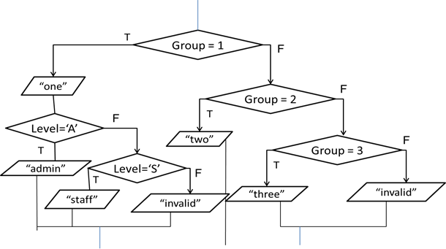

1. Convert the following if/else sequence to a switch statement.

int x;

cin >> x;

if (x == 2)

cout << "x=2";

else if (x==3 || x==5) {

cout << "x=3 or 5";

x++;

}

else if (x==4)

cout << "x=4";

else

cout << "Else.";

1. Part of the code segments below contains error(s). Identify the errors.

string s;

getline (cin,s);

switch (s) {

case "hello":

cout << "hi";

break;

default:

cout << "bye";

break;

}

1. Rewrite the following multi-way if-else statement by using a switch statement:

|  |
| --- |
| if (character == 'A')  cout << "Hello!";  else if (character == 'B')  cout << "Happy Birthday!";  else if (character == 'C')  cout << "Thank you!";  else  cout << "Welcome!"; |

1. The code below can be compiled, but it contains run-time error.

int x;

cout << "Enter a number: ";

cin >> x;

switch(x) {

case 1:

cout << "You typed 1.\n";

case 2:

cout << "You typed 2.\n";

default:

cout << "You did not type 1 or 2.\n";

}

1. What is the error in the code above?
2. What is the output of the code if the user types in 1?
3. Demonstrate how the code above can be improved.
4. Assume that the tuition fee for year 1 and year 4 is **RM1200.45** and **RM2267.30** respectively without considering the **Code**. The fee for year 2 and year 3 is determined by **code** as shown in the table below:

|  |  |  |
| --- | --- | --- |
| **Year** | **Code** | **Fee (RM)** |
| 1 |  | 1200.45 |
| 2 or 3 | A | 1789.00 |
| B | 2005.50 |
| Others | 2200.90 |
| 4 |  | 2267.30 |

Write a **nested** switch statement to assign the **fee** value based on the conditions above.